St. Patrick’s School

Guitar Ensemble App
User Guide
Made by Advait Contractor and Ryan Lim Jun Long
Last updated 25 June 2024
Application Setup 2
Python Installation 2
PIP Installation 2
Entering the folder on the terminal 3
Installing the packages 5
Operation of the app – Normal mode 6
Requesting a Leave-Of-Absence (LOA) 7
Loaning a Guitar 9
Quartermaster Mode (QMs ONLY) 10
Entering the mode 10
Disclaimer about the current available functions 11
Adding Guitars 11
Removing Guitars 11
Resetting Loan Status 11
Bug fix contacts 11

Application Setup
Prior setup is required to ensure that the application runs smoothly. Any any point of the setup, should you feel to clarify something, you may contact Advait (email and phone number written behind to clarify all your doubts on this setup.

Python Installation
To start, please install Python (at least version 3.12.0) from https://www.python.org/downloads/. Once you are done with this step, please ensure that Python is added to PATH successfully so that you can run Python through the command python , python3 or py on the relevant operating system terminal (Powershell, Terminal or Command Prompt). To run commands on your system terminal, enter the command that will run Python (possibilies shown above), and press “Enter” or “return”. This will run Python. To exit, enter exit() . Your Python command and system terminal will differ from system to system.

PIP Installation
This app will also require another one of Python’s features, known as PIP, or the Python Package Manager. To ensure that it has been installed, please run the command python3 -m pip --version . Please cross-check it using the Figures below. The error messages printed may not be the same as Fig 1.1 and Fig 1.2, as it may vary from computer to computer and operating systems.
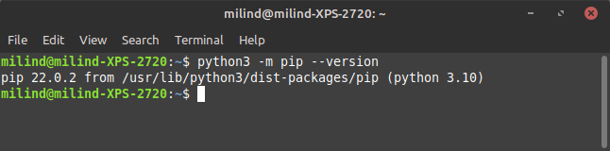
Fig 1.1: Successful Python Package Manager installation

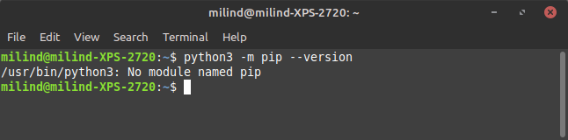
Fig 1.2: Unsuccessful Python Package Manager installation

If the package is not successfully installed, you will not be able to use the application. To rectify this issue, please install PIP using the command python -m ensurepip –upgrade or by appending -m ensurepip –upgrade to the back of the command that launches Python on your computer.

Entering the folder on the terminal
To install the required dependencies for the application to run, open the URL https://github.com/contyadvait/QuarterMasterLoanSystemUpdated on your computer. Once you have opened this page, please press the code button on the top right of the of the website (as shown in Fig. 1.3) and press the “Download ZIP” button on the dropdown (Fig. 1.4)
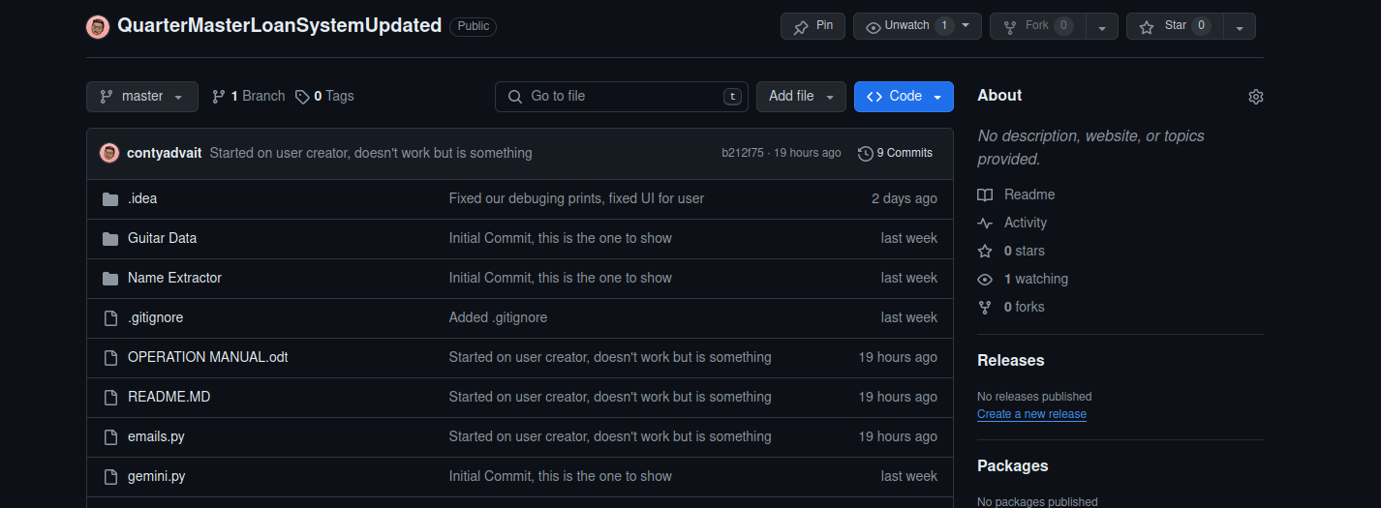
Fig 1.3: The code button on the website

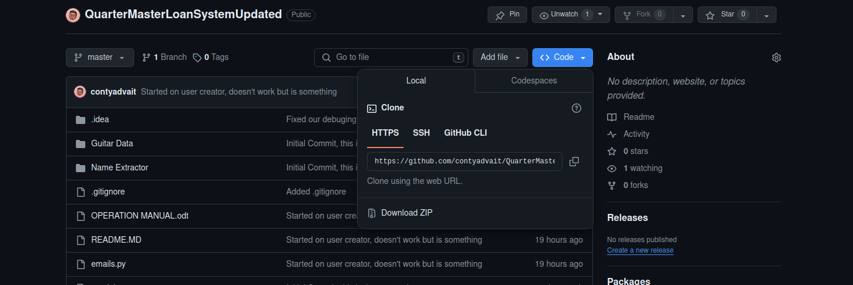
Fig 1.4: The “Download ZIP” button on the code button dropdown

Once you are done, please open your File Explorer, Finder, or your file manager as per your operating system and extract the ZIP file into a folder into a location on your computer that you can easily access. Once you are done, please open the Terminal (Powershell, Command Prompt, or Terminal) and type in cd . Once done typing, switch back to your file manager window with the folder open (Fig 1.5). Drag that into the terminal and press the “Enter” or “return” key on your keyboard.
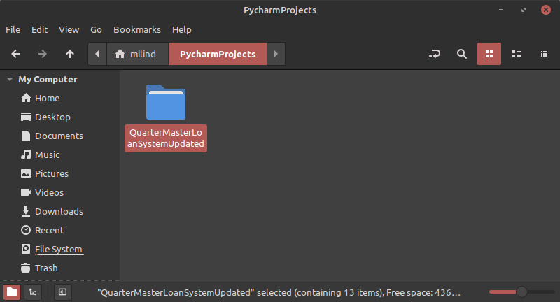
Fig 1.5: A photo of the folder being selected. This folder is to be dragged into the terminal

Once this step has been done, you may move on to installing the required packages.

Installing the packages
To install the relevant packages, type in the command that runs Python on your computer, and add -m pip install -r requirements.txt . Once you are done running this command, there should be no error messages. Your system terminal should look similar to Fig 1.6. If you do face this issue, you may contact Advait (email and phone number written behind) and he will try to fix this issue for you.
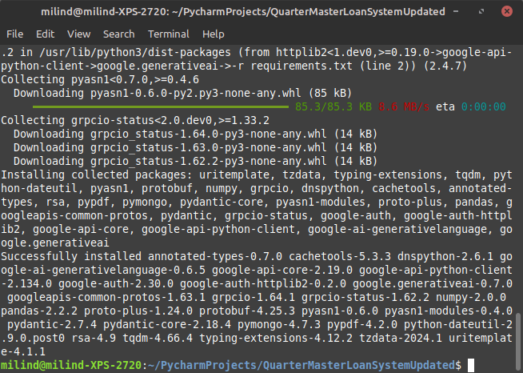
Fig 1.6: A successful module installation

Once the setup is all done, you may move on to Section 2, the operation of the app

Operation of the app – Normal mode
To operate this app as normal, there are some things to take note of. To quit the application anytime while running it, you may press the Control key (May be marked “Ctrl” or with the ^ symbol) and C. This will quit the app. However, you should only do this when the app is not doing anything. This means that the app is asking you for your input (which will be indicated by nothing new appearing, and your text cursor staying at one location). If you do this while the app is doing something (like after you press enter on an input field), the app will cancel all operations. Pasting with the normal keypresses of Control/Command and V will also not work. Instead, you will have to right click and select the option to paste or just right click. Finally, to run the app, start by entering ls or dir (depending on your system) to ensure that your terminal is configured correctly. The files should should look similar to the output of the command as shown below, in Figure 2.1
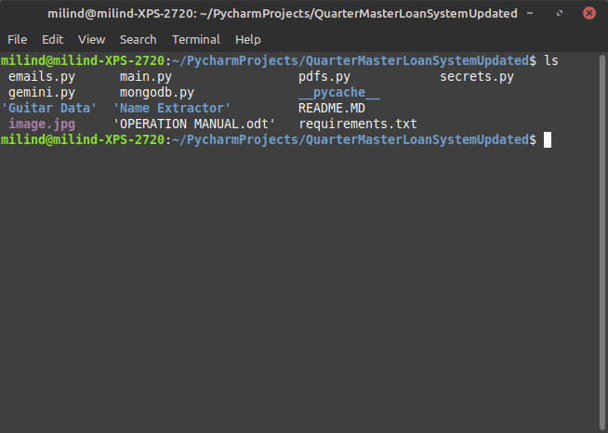
Fig 2.1: The output that should be shown. The colours will be slightly different, however the output will remain roughly the same for all computers.
If the result is not the same, please refer to Entering the folder on the terminal on Page 5. Once you have checked it, you may run python3 main.py , replacing python3 wil whatever your command that runs Python is. When running the app, the app will give you a couple of options, with a number written in square brackets ([1], [2], [3], etc.). Do not enter the option name, always enter the numbers written in the square brackets.

Requesting a Leave-Of-Absence (LOA)
To request a Leave-Of-Absence from CCA, start by running the app. When you are asked what would you like to do (Fig 2.2), enter 2 and press the Enter key.

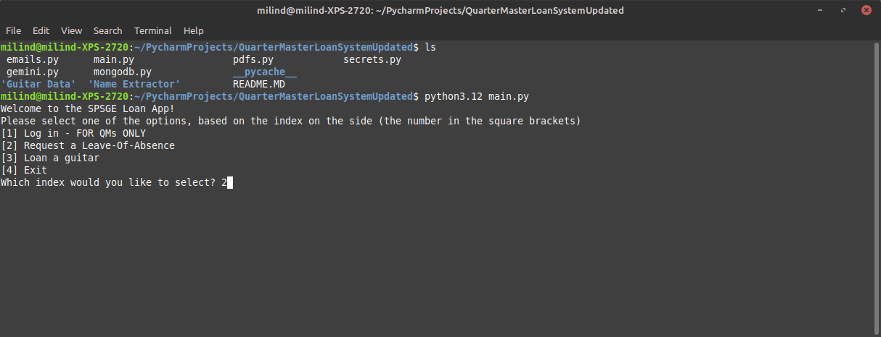
Fig 2.2: Option 2 being entered.
After this, enter the date you are not coming for CCA. This date should be in the DDMMYYYY format without any slashes. For example, if you are not able to come on 4th July 2024, enter 04072024 (as shown Fig 2.3).

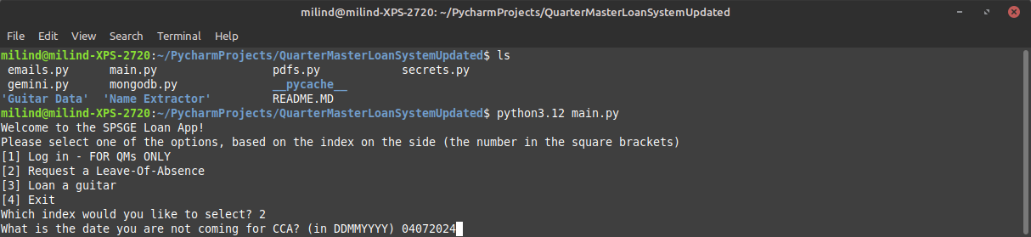
Fig 2.3: Date in the example being entered.

You will be then prompted to give a reason for not coming on that date. Enter this reason. Once you are done with that, enter your name, as it is in the attendence list. For example, if you are Ryan Lim, you will enter Ryan Lim Jun Long (Lin Junlong) in the field. This is not completely case-sensitive, as only the letters used matter, but you may enter your name in lower-case, as shown in Fig 2.4
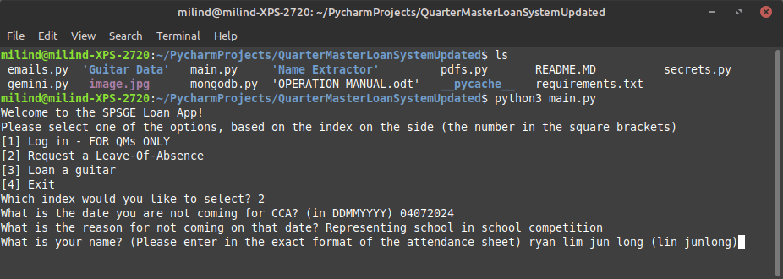
Fig 2.4: Entering name
Finally, the application will end by not printing anything for a short while once you press enter. DO NOT QUIT THE APPLICATION THROUGH CONTROL + C. After which, an email will be sent to the teachers and the secretary about your Leave-Of-Absence on that day. You will exit Python at this point and written back to the original terminal, as shown in Fig 2.5
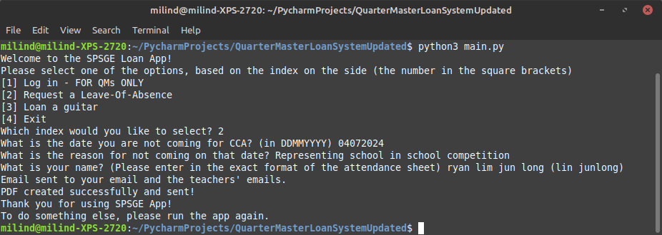
Fig 2.5: End of the programme, and returning back to the system terminal

You have successfully applied for your leave of absence on that day.

Loaning a Guitar
The process of loaning a guitar is similar to the process of applying for a Leave-Of-Absence. To start, run the application. Enter index 3 when asked about which index you would like to use. Enter your name, based on your attendance sheet. This step is the same as entering your name for the Leave-Of-Absence. Once you are done with this, resize your system terminal window to be full-screened. This is because a text-based table will be shown of all the guitars. Not all the results will fit, and you can use the scroll wheel to move up and down the table. (Fig 2.6).
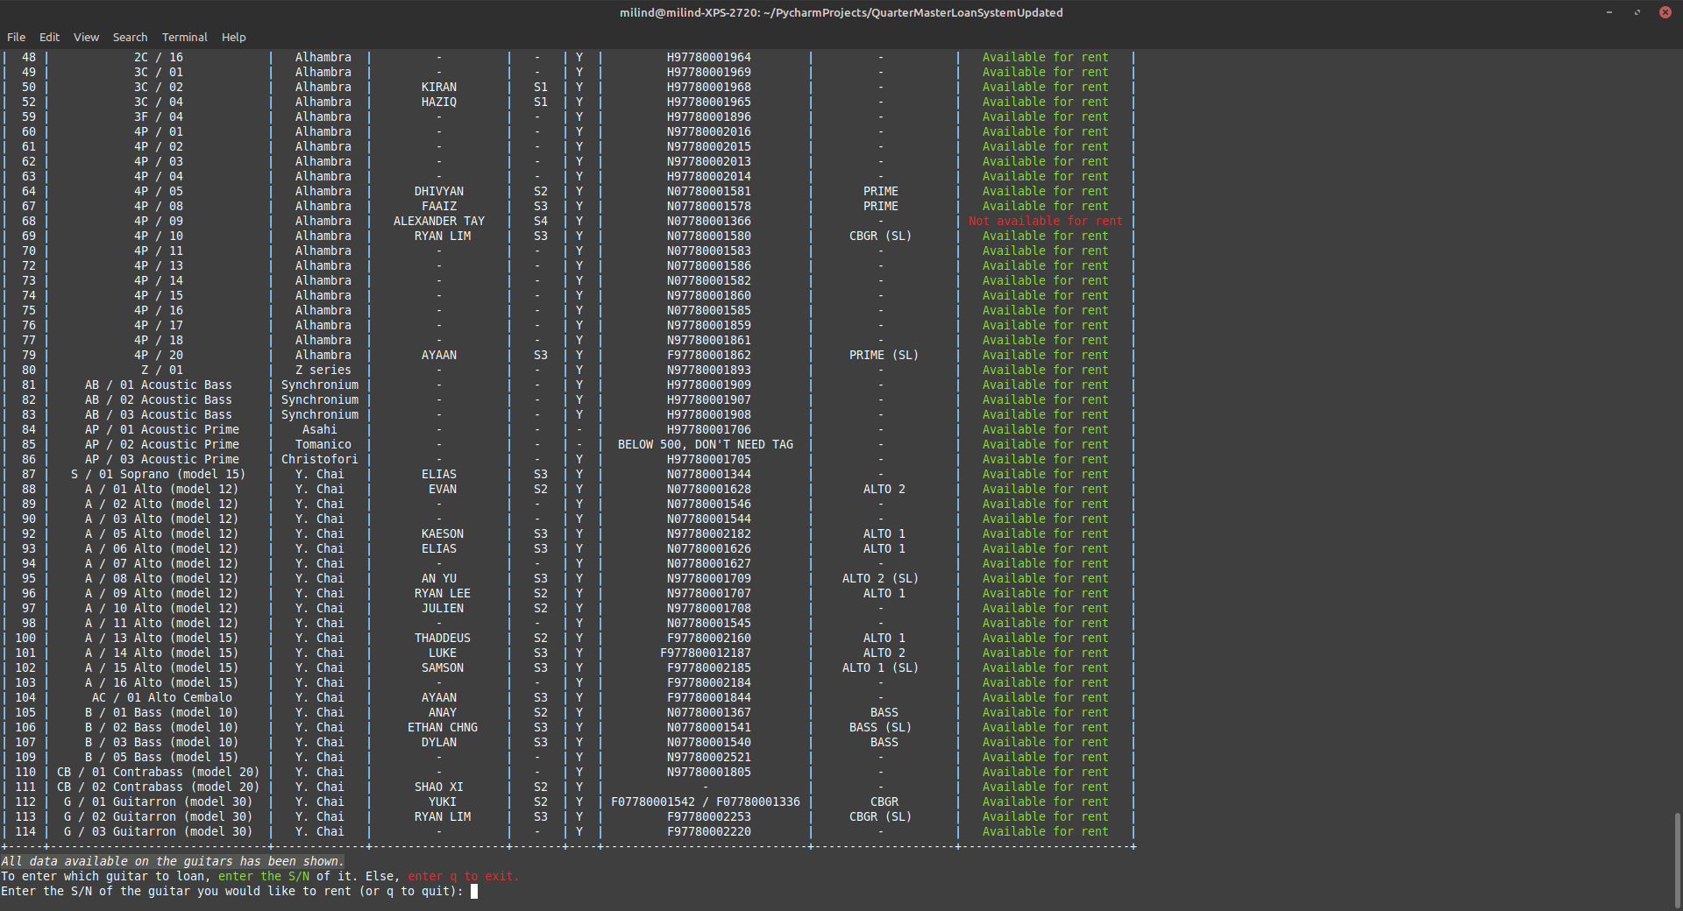
Fig 2.6: All the guitars available for loans, displayed in a table.

Now, you may scroll through the whole list of loaned guitars. Any guitar that is marked as green, is a guitar available for rent. At this stage, you can enter q to exit Python safely, or you can enter the S/N (the number in the first column) of that guitar. For example, if I would like to rent the guitar G/03 Guitarron (Model 30) (the last guitar in the table), I can enter number 114 and press enter. The application will check again to ensure that it is available, and will ask you to confirm it with [Y/n (to exit app)] . This means that if you want to loan the guitar, you may enter y , which stands for Yes, or n , which stands for No. Should you choose to select no, the app will automatically quit itself. You will be prompted for your form class and your email address. Once you are done with this, you have successfully loaned your guitar! The app will automatically exit safely once you are done.

Quartermaster Mode (QMs ONLY)
These are functions of the app that are only available for quarter masters. If you are not a quartermaster, you do not need to know anything other then you cannot use option [1] of the main app.

Entering the mode
To enter the mode, run the app as usual. Enter option 1 when you are prompted with what to do. At this stage, you will need your user ID and password ready. Enter this when prompted. When entering your user ID and password, you should just type normally. Although you have typed something on your keyboard, you will not be able to see anything in the system terminal. This is a completely normal behavior of the application and you do not need to be worried about it. This has been done for your privacy. To know wether you have successfully entered the mode, refer to Figure 3.1 and ensure that your system terminal output looks something along the lines of that:
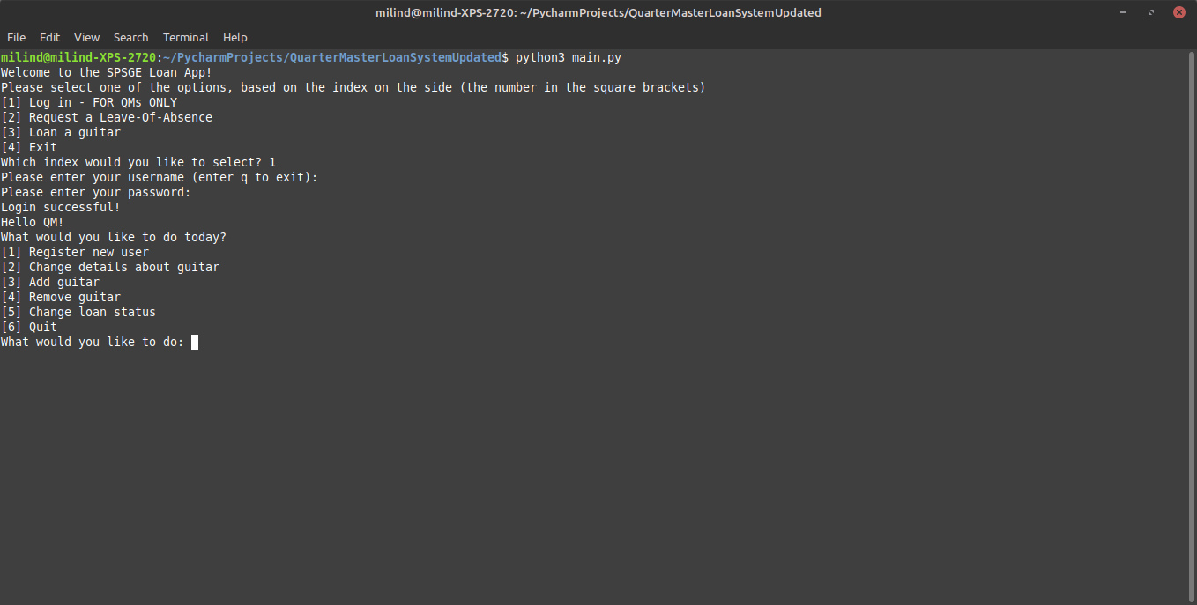
Fig 3.1: Successful enterance of the QM mode

Disclaimer about the current available functions
Currently, not all functions are available. These functions will be rolled out with updates over time. Currently, option number [2] is currently not available. However, these will be soon available with updates. You will be informed about them by us soon.

Adding Guitars
To add a guitar, select option number [3] from the menu. After that, just follow the prompts. The prompts that are not shown, will be either set as blank. The prompts that are blank will be changeable through option number [2] once it comes out. The app will only autogenerate an S/N, the parameter that is selected by the user.

Removing Guitars
To remove a guitar, select option number [4] from the menu. After which, select the S/N of the guitar you would like to remove. Once you have confirmed it, this guitar will be made no longer available for loans, and no student can loan it.

Resetting Loan Status
Currently, this is the only major item available to the QM. To reset it, the steps are similar to loaning one. Select option number [5] in the QM mode and select the Serial Number (the S/N column) of the guitar when prompted to do so. From here, you will be asked to confirm that you are resetting this guitar. Once you are done with this, this guitar will be available to everyone else again for loans of the guitar.

Bug fix contacts
Should you have issues with the application at any point through the operation of it, you may contact the lead software engineer of this application at the details below:
LEAD SOFTWARE ENGINEER
Advait Contractor
advaitthepro@outlook.com
(click on the email above to send an email)

